
Annals of Agrarian Science vol. 14, no. 3, 2016
Ecological stability and plasticity of soybean varieties
Liudmila Bilyavska, Anna Diyanova
Poltava State Agrarian Academy
1/3 Skovorody Str., Poltava, 36003, Ukraine
Received 27 April 2016; accepted

Abstract

The article gives analysis of practical value of soybean varieties according to productivity and ecological plasticity in different climatic provinces in Ukraine. Ecological estimation of soybean varieties using method of Eberhart S.A. and Rassel W. K. has been made. Variety plasticity and adaptive potential have been defined on the basis of this estimation. It has been established that varieties Almaz and Diona were the best varieties according to the results of ecological variety studies. The most favourable regions for cultivation of up-to-date soybean varieties have been chosen. Variety Almaz has been defined as the most intensive and plastic soybean variety (average yield in years was 2.66 – 2.93 t/hа). Varieties Antratsit and Ametist also have shown high plasticity. Varieties are recommended for cultivation in steppe and forest-steppe in Ukraine. The higher numerical value of coefficient the more variety reaction on improving cultivation conditions. Thus, varieties with higher regression coefficient and lower mean square value have optimal indicators.
High sensitivity of some varieties to unfavorable cultivation conditions offen narrows area of these varieties distribution and limits their general distribution. On the basis of examination of soybean varieties in different regions we can predict genetically specific degree of yield stability (adaptation to cultivation conditions).

Keywords: Soybean, Variety, Value, Yield, Plasticity, Ecological stability, Variety study.

- Introduction

Ecological plasticity and yield stability in different years and under different cultivation conditions are very important for variety characteristics [1, 2]. Variety plasticity is a quality to form satisfactory yield being grown in different conditions. Variety stability is an indicator of resistance in realization of selective and genetic genotype properties being grown in different conditions [3]. Plasticity and stability characterize homeostatics of variety according to cultivation conditions and ability to adapt [4].
These researches have been done by methodology of Eberhart S.A., Rassel [5]. These scientists offered to estimate ecological plasticity of varieties according to two indicators such as coefficient of regression and mean square deviation from regression lines or stability variants which characterize in the first case their reaction in changed cultivation conditions.
The higher numerical value of coefficient the more variety reaction on improving cultivation conditions. Thus, varieties with higher regression coefficient and lower mean square value have optimal indicators.
High sensitivity of some varieties toun favorable cultivation conditions offen narrows area of these varieties distribution and limits their general distribution. On the basis ofexaminationofsoybeanvarietiesindifferentregionswecanpredictgeneticallyspecific degree of yield stability (adaptation to cultivation conditions).

- Objectives and methods

Research material was varieties of Ukrainian selection. These varieties were ecologically tested in different provinces in Ukraine. These provinces are distinguished by soil and climatic conditions. Phenological observations, data record and analysis have been made in accordance with methodology of state examination of crops [6,7]. Method of Eberhart S. A. and Rassel W. A. was used for determination of stability parameters (agroecological estimation of soybean varieties) [5]. Mathematical processing of yield data was done by methods of dispersion, variation, correlated analysis and methods of estimation of considerable difference of average sampling by t-criterion [8]. Variety adaptation was determined on the basis of the results of ecological researches.

- Results and analysis

Interaction of yield of studied soybean varieties has been established taking into account diversity of weather conditions, duration of vegetation period and yield stability(Table 1).

Table 1. Yield of soybean varieties depending on influence of weather condition of the region, t/hа

Variety | Year |  |  |  | S | max | min | R = max - min
Variety | 2009 | 2010 | 2011
Annushka | 2.00 | 2.36 | 2.36 | 2.24 | 0.21 | 2.36 | 2.00 | 0.36
Legenda | 1.98 | 1.92 | 2.41 | 2.10 | 0.27 | 2.41 | 1.92 | 0.49
Diona | 2.07 | 2.22 | 2.21 | 2.17 | 0.08 | 2.22 | 2.07 | 0.15
Vorskla | 2.34 | 2.29 | 2.09 | 2.24 | 0.13 | 2.34 | 2.09 | 0.25
Almaz | 2.66 | 2.72 | 2.93 | 2.77 | 0.14 | 2.93 | 2.66 | 0.27
Ametist | 2.26 | 2.38 | 2.53 | 2.39 | 0.14 | 2.53 | 2.26 | 0.27
Antratsit | 2.35 | 2.67 | 2.71 | 2.58 | 0.20 | 2.71 | 2.35 | 0.36
Belosnezhka | 2.06 | 2.02 | 2.06 | 2.05 | 0.02 | 2.06 | 2.02 | 0.04
Romantika | 2.05 | 2.25 | 2.40 | 2.23 | 0.18 | 2.40 | 2.05 | 0.35
Kievskaya 98 | 2.15 | 2.11 | 2.43 | 2.23 | 0.17 | 2.43 | 2.11 | 0.32
Suzirya | 2.39 | 2.21 | 2.38 | 2.33 | 0.10 | 2.39 | 2.21 | 0.18

Research results given in the table have demonstrated that variety Almaz is an intensive variety that during three-year research had on 2.66 t/hа, 2.72 t/hа and 2.93 t/hа higher yield than other varieties. Variety Almaz also was them ostplasticas in research years average yield of this variety was the highest, at the level of 2.77 t/hа. Only varieties Antratsit and Ametist with average yield of 2.58 t/hа and 2.39 t/hа accordingly got closer to the productivity level of variety Almaz. Varieties Belosnezhka, Diona and Suzirya were stable according to the level of yield.
Calculation of regression coefficient allowed to estimate ecological plasticity of soybean varieties (Fig. 1).

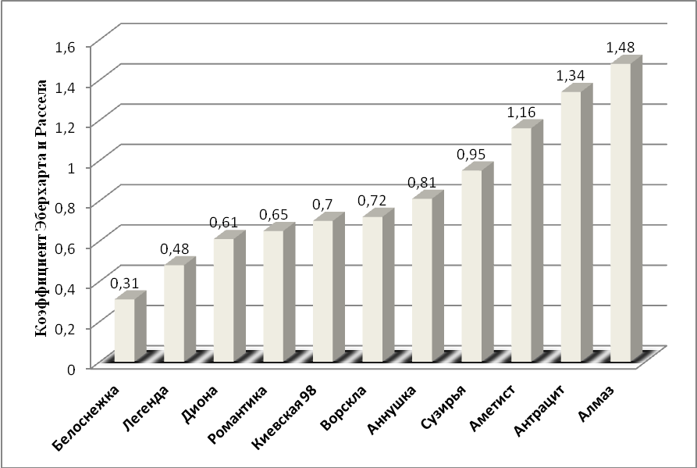
Fig. 1. Estimation of soybean varieties using Eberhart and Rassel coefficient

Indicator of this coefficient in different conditions characterizes general tendency of changes of each variety yield. If regression coefficient approaches to 1 (b_{i} ≅ 1.0), variety of such type is considered to be plastic if there is complex of unfavorable condition. Varieties Belosnezka, Legenda, Diona, Romantika, Kievskaya 98, Vorskla, Annushka and Suzirya were plastic and varieties Ametist, Antratsit and Almaz were high-plastic among studied soybean varieties.
The degree of yield stability is characterized by indicator of deviation from total variance. The more negative indicator of deviation from total variance, the more maximal yield stability of the variety. Variety is plastic if deviation from regression approaches to zero. Varieties with positive indicator and considerably far from zero are high-plastic. Stability and plasticity of soybean varieties depending on ecological conditions of cultivation region are given in Fig. 2.

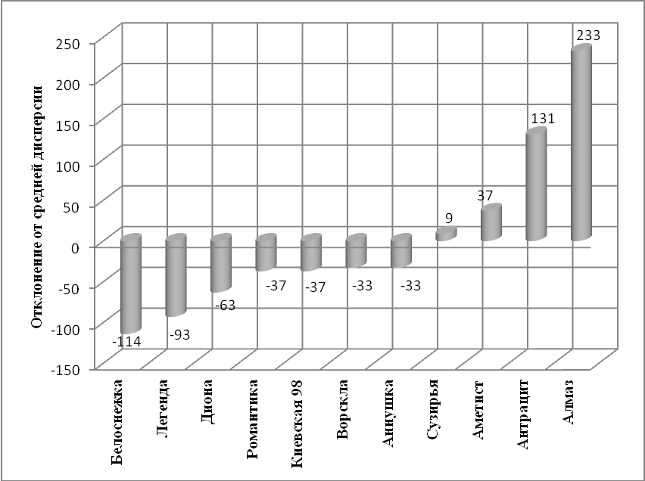
Fig. 2. Dependence of stability and plasticity of soybean varieties upon ecological conditions of cultivation region

Ecological estimation of soybean varieties has been made in six provinces (climatic regionalization of soil and climatic zones of Ukraine) [9] according to following statistical indicators: average yield, dispersion and standard deviation from arithmetic mean, maximal, minimal value and amplitude of yield indicator, mistake of arithmetic mean, determination of homeostatics and coefficient of variety agronomic stability.
The results of ecological study of soybean varieties in 2005 year are shown in the table 2.
The best varieties according to the results of ecological study in comparison with average yield (2.47 t/hа) of the experiment were varieties Almaz and Diona (2.73t/hа and 2.50 t/hа respectively). Variety Yug-30 (2.44 t/ha) was close to them. Provinces Dnestrovsko-Dneprovskaya forest-steppe, Prichernomorskaya middle steppe and Donetsko-Donskaya north steppe are the most favourable for cultivation of new soybean varieties. Average increases in comparison with average yield in the experiment were 1.06t/hа., 0,10t/hа and 0.01 t/hа.

Table 2.Yield of soybean varieties, t/hа(the results of ecological study, 2005 year)
Provinces in Ukraine | Soybean varieties |  |  |  | Mean | Diference
Provinces in Ukraine | Yug-30 | Almaz | Diona | Anzhelika | Mean | Diference
Dnestrovsko-Dneprovskaya forest steppe | 3.59 | 3.84 | 3.62 | 3.05 | 3.53 | 1.06
Prichernomorskaya middle steppe | 2.56 | 3.02 | 2.84 | 1.85 | 2.57 | 0.10
Donetsko-Donskaya north steppe | 2.38 | 2.82 | 2.3 | 2.41 | 2.48 | 0.01
Levoberezhno- Dneprovskayaforeststeppe | 1.77 | 2.18 | 2.03 | 1.87 | 1.96 | -0.51
Srednerusskaya forest steppe | 2.26 | 2.31 | 2.04 | 2.18 | 2.20 | -0.27
Levoberezhno-Dneprovskaya north steppe | 2.10 | 2.22 | 2.19 | 1.84 | 2.09 | -0.38
Mean | 2.44 | 2.73 | 2.50 | 2.20 | 2.47
Standard deviation | 0.62 | 0.64 | 0.62 | 0.47
Max – maximal yield | 3.59 | 3.84 | 3.62 | 3.05
Min – minimal yield | 1.77 | 2.18 | 2.03 | 1.84
R – amplitude of fluctuations of yield | 1.82 | 1.66 | 1.59 | 1.21
Mistake of arithmetic mean | 0.25 | 0.26 | 0.25 | 0.19
Vе,% – coefficient of variance | 2.55 | 2.35 | 2.49 | 2.16
Hom – homeostatic | 0.10 | 0.12 | 0.10 | 0.10
As – coefficient of agronomic stability | 74.5 | 76.5 | 75.1 | 78.4

On the basis of a number of statistical indicators we can say about dependence of variety stability under influence of ecological conditions of the region. Thus, we can draw a conclusion about degree of variety stability under influence of different ecological conditions of the regions taking into account variation amplitude (difference between maximal and minimal yield). The lower this indicator the more stable variety. In compliance with this indicator varieties were differentiated in the order of decrease: Anzhelika, Yug-30, Diona and Almaz.
The mistake of arithmetic mean has been used for characteristics of arithmetic mean at 5% value level (x ± t₀₅s_{x}). The less number of mean fluctuations the more reliable result. Taking into account mistake of arithmetic mean soybean varieties have been placed in the order analogical to variation amplitude: Anzhelika, Yug-30, Diona and Almaz.
Ecological coefficient of variance characterized the degree of arithmetic mean changeability (to 10% – low diversity, 10-20 – middle and>20 – high). Thus, all studied soybean varieties were included into the group with low degree of changebility to 10%.
Homeostatics characterized selective value of variety genotype. The higher this indicator the greater possibility of getting this variety into following selective process. According to this indicator studied varieties have placed in the following order: variety Almaz was the most valuable, varieties Anzhelika, Yug-30 and Diona had identical value.
Coefficient of agronomic stability of the variety characterized indicator of economic value of variety. Varieties with indicator higher than 70 % will be optimal for cultivation. All studied soybean varieties correspond to this level. In the group they have placed in such order: Anzhelika, Almaz, Diona and Yug-30.
Estimation of specific variety value that is stipulated by both genetic variety potential (Еі) and stability of realization (Ri) allows to determine value of each of them and offer complex estimation of the level of grain yield, line of indicators of technological quality and disease resistance.
Calculation of specific significance of soybean varieties according to crop yield are given in the table 3.

Table 3. Estimation of soybean varieties yield, t/hа
Soybean variety,  N | Province (research territory), r |  |  |  |  |  |  | 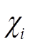 |  | 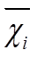 | E_{i} |  |  | R_{i} |  | βi²
Soybean variety,  N | Dnestrovsko-Dneprovskaya forest-steppe | Prichernomorskaya middle-steppe | Donetsko-Donskaya north-steppe | Left-bank-Dneprovskaya forest-steppe | Srednerusskaya forest-steppe | Left-bank-Dneprovskaya северостепная
Yug-30 | 3.59 | 2.56 | 2.4 | 1.77 | 2.26 |  | 2.1 | 14.7 |  | 2.4 | -0.03 |  |  | 1.09 |  | 0.04
Almaz | 3.84 | 3.02 | 2.8 | 2.18 | 2.31 |  | 2.2 | 16.4 |  | 2.7 | 0.26 |  |  | 1.12 |  | 0.06
Diona | 3.62 | 2.84 | 2.3 | 2.03 | 2.04 |  | 2.2 | 15.0 |  | 2.5 | 0.03 |  |  | 1.06 |  | 0.14
Anzhe-lika | 3.05 | 1.85 | 2.4 | 1.87 | 2.18 |  | 1.8 | 13.2 |  | 2.2 | -0.27 |  |  | 0.73 |  | 0.27
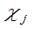 | 10.3 | 9.90 | 7.90 | 8.80 | 8.40 |  | 10.3 | 59.3 |  | 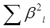 |  |  |  |  |  | 0.51
 | 2.60 | 2.50 | 2.00 | 2.20 | 2.10 |  | 2.60 | 2.5 |  | G_{факт. =} |  |  |  |  |  | 0.41
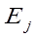 | 0.10 | 0.01 | -0.51 | -0.27 | -0.38 |  | 0,1 | G₀₅ за ст.воли3 и 6 |  |  |  |  |  |  |  | 0.71
N = | 4 | r = | 6

Rank estimation of practica lvalue of soybean varieties according to grain yield have been made too. The lower rank of the studied variety in comparison with zoned variety the higher economic value of this variety. Most of the studied varieties (except variety Anzelika) belong to the second rank according to genotypical effect (yield indicator). According to plasticity they also belong to the second rank. Varieties Almaz, Diona andYug 30 (each had 4) were the best by the sum of ranks.
According to mass of 1000 grain, grain humidity and duration of vegetation period varieties differed only by genotypical effect. Advantage on ranges have sorts: Variety Anzhelika had rank 1, varieties Almaz and Diona hadrank 2 and Yug 30 had rank 3. All varieties belong to the second rank in compliance with plasticity .According to the sum of ranks varieties have placed in the same order.
It is necessary to admit that variety Almaz was the best according to resistance to lodging, fall, drought and also resistance to ascochyta-leaf spot and leaf blotch.

- Conclusion

1. Almaz is the most intensive variety according to ecological estimation of soybean varieties. During three research years this variety showed maximal plasticity (average yield was 2.77 t/hа). Variety Almaz has won soybean varieties Antratsit and Ametist just by little.
2. Provinces Dnestrovsko-Dneprovskaya forest steppe, Prichernomorskaya middle steppe and Donetsko-Donskaya north steppe included in “soybean belt of Ukraine” were the most favourable for cultivation of new soybean varieties. The main sown areas of this crop are concentrated on these territories.
3. VarietyAlmaz (41) has got the first place according to the sum of ranks of genotypical and ecological estimations of effects on the basis of ranking estimation of soybean varieties.Variety Almaz is photoperiodically neutral, cold and drought-resistant.

References
[1] А.А. Zhuchenko, Adaptive plant breeding. Breeding of productive varieties,Biology. M.: Znanie, № 12. (1986), PP. 4–30 (in Russian).
[2] А.К. Leshchenko, V.G. Mikhailov, Plasticity of soybean varieties according to seed productivity, Selection and Seed growing. Kiev, (1975) Issue. 29, PP. 55–60 (in Ukraine).
[3] P.P. Litun, Interaction of genotype-medium in genetic and selective researches and ways of its studying, – Collection: Problems of selection and estimation of selective material. К.: Naukova dumka, (1980), PP. 63–92 (in Ukraine).
[4] А.P. Vashchenko, N.V.Mudrik, P.P.Fisenko, L.А. Dega, Soybean on Far East. Vladivostok: Dalnauka, (2010), PP. 435 (in Russian).
[5] S.A. Eberhart, W.A. Russell, Stability parameters for comparing varieties, Crop Sci, (1966) V. 6, № 1, PP. 36–40
[6] Methodology of state seed-trial of crops.– Edited by V.V. Volkodav. – К., (2000) Issue 1 (General part), PP. 100 (in Ukraine).
[7] Methodology of state seed-trial of crops, Cereals and legumes. К.: Alefa, (2000), PP. 68 (in Ukraine).
[8] B.А. Dospekhov,Methodology of field experiment. М.: Kolos, (1979), PP. 416 (in Russian).
[9] Provinces in Ukraine (map) [Electronic sourse], access, https://www.bagazhznaniy.ru/obrazovanie/zapadnoukrainskaya-provinciya (in Ukraine).

